S Augustine’s RC High School

Here are some of the key members of staff who will support you in your time at St Augustine’s in addition to all our classroom teachers.

Senior Leadership Team

The Senior Leadership Team which consists or the Headteacher (Mr McGee), the Deputes (Mrs Chrystal and Mrs Baird), the Business Manager (Mr Carter), and a Year Head (Mr Dalgleish).

Mr McGee | Mrs Chrystal | Mrs Baird
Mr Dalgleish | Mr Carter

Integrated Pupil Support Team

You will have a Pupil Support Leader (Mrs Kelly, Mr Banks/ Miss Cox or Mrs McKillop) who is there to support you throughout your time at school. You will hopefully have met them during your 3 day visit. Your parents can also meet them at the parents’ evening and can contact them at any point on 0131 334 6801 if there is anything they are concerned about.

 | 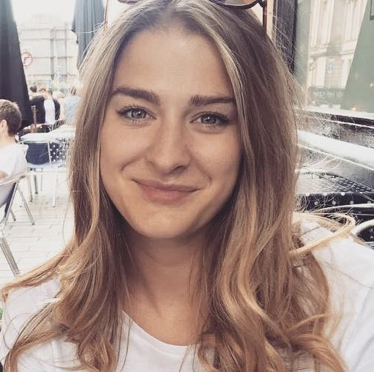
Miss Kelly | Miss Cox (Mr Banks is away at present) | Mrs McKillop
Our Pupil Support Team also includes our Support for Learning Leader (Mrs Heeps) and a Mrs Zamarlik.

They work in our Pupil Support Base where Mrs Logan will welcome you and help you find the correct person you are looking for.
 |  | 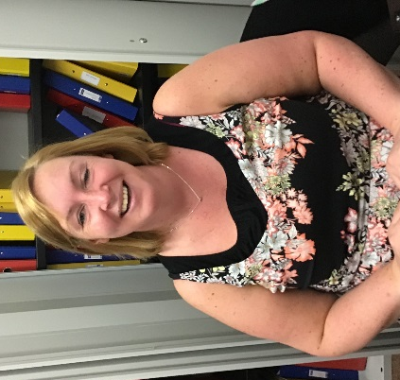
Mrs Heeps | Mrs Zamarlik | Mrs Logan
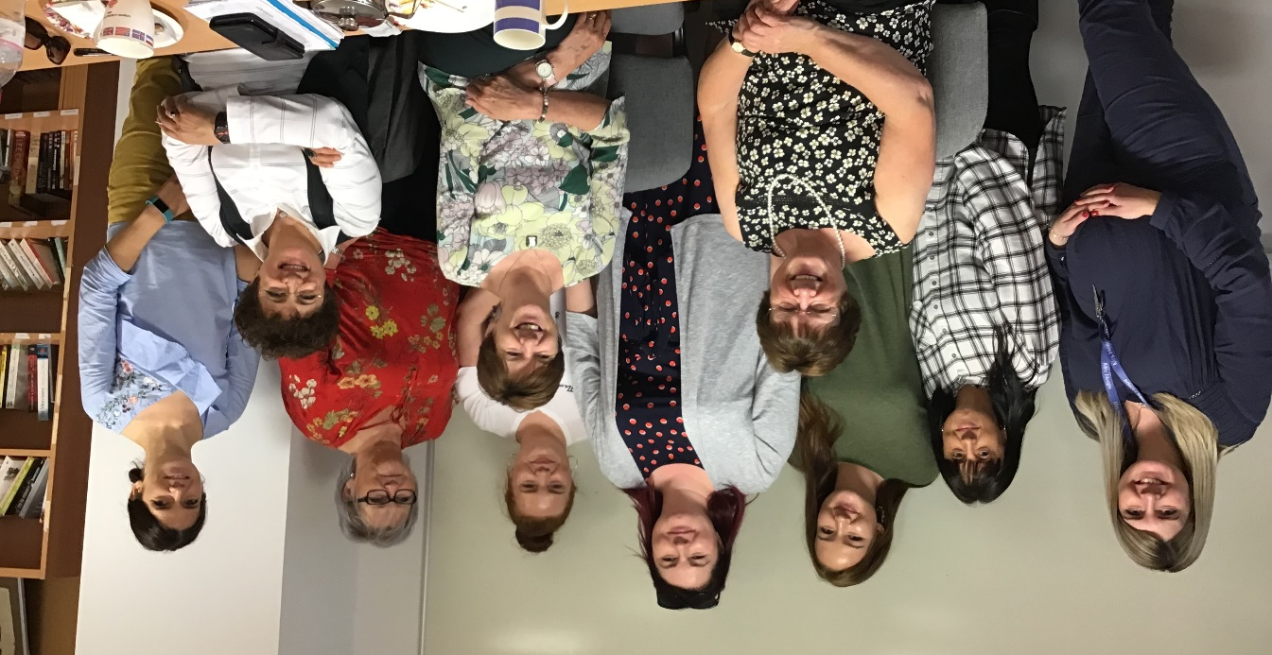
Our Pupil Support Assistants will also help you in your classrooms.

We also have our Development Officer for Emotional Wellbeing (Mrs Mcdonald) who runs our Chat Room; our Development Officer for Inclusion (Mr Milne) who runs our Hub and our Family Liaison and Pupil Support Officer (Mrs Gibson – known as Claire)

 |  | 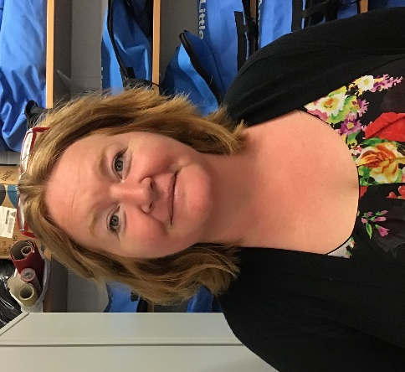
Mrs Mcdonald | Mr Milne | Mrs Gibson - Claire

