Times of the day
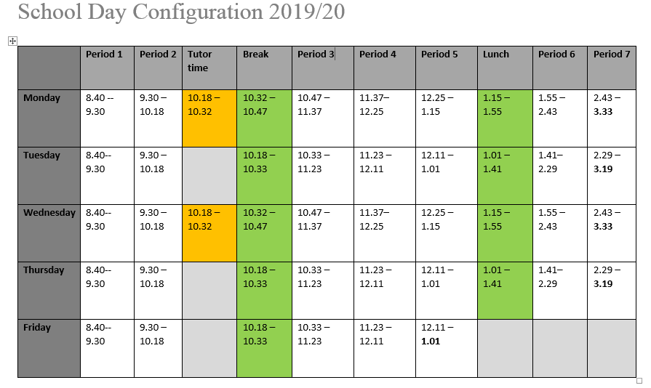

School procedures – these will be explained further to you during your first week

How lunch cards work. To buy lunch you need to use a OneScot card or a pin number which you will be given by the school in August. You may have used a similar “cashless catering system” in Primary. You can put money onto your card at the start of the day or at breaktime in the machines in the dining room.

What to do if you are late–If you are late but arrive before 9am you must sign in in the dining room. You must then report to Maths Room 4 at lunchtime or break on a Friday or you may get a Friday afternoon detention. If you arrive after 9am you must sign in at the front office and report to Maths Room 4 at lunch. Your parents will receive a ‘late call’ if you are late.

What to do if you are absent - If you know in advance that you are going to be absent, your parents must phone the school or write a letter explaining why you will not be in.
If you are absent and your parents have not written a letter or phoned the school, they will receive an Absence call which asks you to let us know why you are off school.
The school phone number is 334 6801

What to do if you are feeling sick? – Pupils should report to the sick bay at the front office if they feel unwell. If you need to go home, Mrs Divine may phone your parents and ask them to come and collect you. You must not leave school without permission or phone parents to come and collect you. OUR SCHOOL OFFICE WILL CALL THEM.

