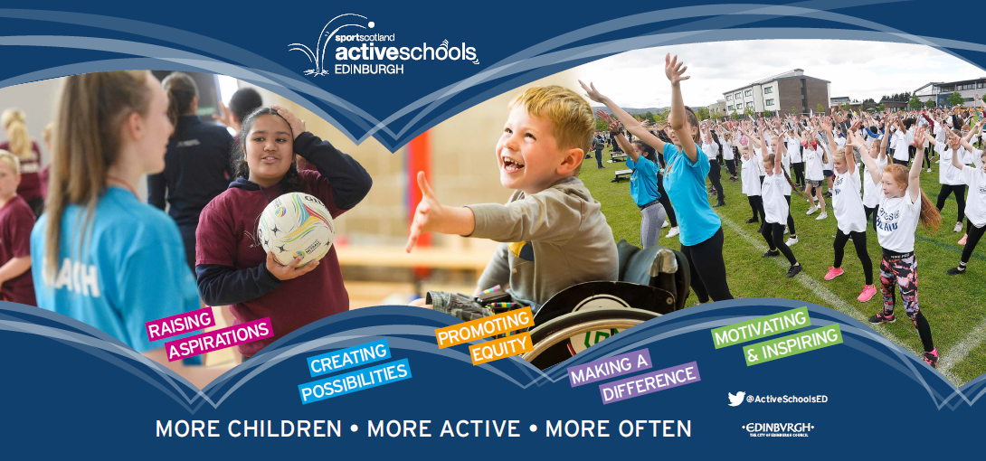

Bookings Open – 31 August 2022
Book fast online:
Activity detail (joininedinburgh.org)
Click on this link then click on the green BOOK ONLINE box add your details and tick which clubs you
wish to join. You can join as many as you want and join at any time in the year.
School code is STA-201
St Augustine’s HS School
Active Schools Sports Clubs
September 2022-June 2023
St AUGUSTINE’S HIGH SCHOOL
Active Schools Co-ordinator
Mrs Damen
Text: 07769 922742
Email:fiona.damen@ea.edin.sch.uk

Clubs at St Augustine’s High School this year are:
Spaces are allocated on a first come first served basis and classes have limited spaces specially swimming clubs. To avoid disappointment please book as soon as possible click on the link. Clubs are subject to change, and all taken by volunteer staff.

Activity | Day | Age | Time | Dates | Venue | Code
SPORT |  |  |  | Clubs will run all year  No clubs on when the school is closed pupils |  | JOIN IN CODE
Netball  S4-6 | MONDAY | S4-6 | 3.30-430 | 5/9/22 onwards | Games Hall | STA-201
GIRLS SWIMMING  S1-6 | MONDAY | S1-6 | 3.30-4.30 | 5/9/22 onwards | Swim pool | STA-201
Netball  S1-3 | TUESDAY | S1-3 | 3.30-4.30 | 6/9/22 onwards | Games hall | STA-201
Girls Football S1-6 | TUESDAY | S1-6 | 3.30-4.30 | 4/10/22 onwards | Meet in PE then to astro | STA-201
KPOP  Dance Club | Tuesday | S1-6 | 3.30-4.30 | 4/10/22 onwards | Fitness Suite | STA-201
VOLLEYBALL CLUB - RECREATIONAL | WEDNESDAY | S4-6  Recreational | 3.30-4.15 | 7/9/22 onwards | Games Hall and Gym | STA-201
BASKETBALL  S4-6 | WEDNESDAY | S4-6 | 3.30-4.30 | 7/9/22 onwards | Games Hall and Gym | STA-201
FOOTBALL  S1-3 | WEDNESDAY | S1-3 | 3.30-4.30 | 7/9/22 onwards | Meet at PE then 3G pitch | STA-201
FUN DANCE  S1-3 | WEDNESDAY | S1-3 | 3.30-4.30 | 7/9/22 onwards | Fitness suite | STA-201
Rugby  S1-4 | WEDNESDAY | S1-4 | 3.30-4.30 | 7/9/22 onwards | Meet at PE then out to rugby pitch | STA-201
Junior  BASKETBALL  S1-3 | THURSDAY | S1-3 | 3.30-4.30 | 8/9/22 onwards | Games Hall | STA-201
BOYS SWIMMING | THURSDAY | S1-6 | 3.30-4.30 | To be confirmed | Swim Pool | STA-201
FOOTBALL  S4- S6 |  | S4-6 | 3.30-4.30 |  | PE base then the 3G pitch | STA-201

Please note any senior football information will follow and we hope to start a boy’s swim club in the next few weeks
Please note the school charge only £10 for the entire year of sports membership, you can attend as many clubs as you wish for the whole year. This money covers coaching, strips, equipment, travel, and referee costs. If you receive Free School Meals, then the clubs are free.
£10 is payable via Parent Pay or see Mr Murray in PE, thanks.

How do I book my child’s place?
Click on QR code

Online Booking @
Activity detail (joininedinburgh.org)
OR
www.joininedinburgh.org
AND ENTER STA-201
Then click on the green ‘book online’ box and add details (QR code at foot of letter)

BOOKING CODE FOR SCHOOL IS STA-200

GET ACTIVE WITH ACTIVE SCHOOLS
BOOK INTO AN EXTRA CURRICULAR SESSION

Volunteer with Active Schools

We are recruiting volunteers in a variety of roles to help us provide as many opportunities as possible for children to take part in sport and physical activity! We will provide full training and support. If you want to find out more please contact me.

TEXT Mrs Damen on 07769922742
or email fiona.damen@ea.edin.sch.uk

Additional Support Needs

If you feel your child needs additional support to take part in our clubs, please contact us. See below a link to more opportunities and events for children with Additional Support Needs in Edinburgh

www.joininedinburgh.org/sports/active-schools/inclusion/

Swimming information | Sites for swim lesson information
CLUB | INFORMATION
West Edinburgh Stingrays Swimming and Water Polo Club | Various swim lessons and venues  https://bookwhen.com/westingrays
Hearts Swim School | Tuesdays 4-6pm  St Augustine’s/Forrester’s  High School Pool  www.swimhearts.com

Please note the programme is subject to change – please check the website for the most up to date information.
With COVID restrictions now easing. Please continue to follow our guidelines and the government guidelines regarding self-isolation, if you child/home has symptoms please contact SCHOOL/ASC immediately and don't attend, many thanks .

