WELCOME

TO

S AUGUSTINE’S

RC HIGH SCHOOL

P7 TRANSITION

PUPIL HANDBOOK

PUPIL NAME:

FORM CLASS:

PRACTICAL SET:

PUPIL SUPPORT LEADER:

**THE SCHOOL PRAYER**

****God Our Father

Let us pray

That there will be respect for our world

Peace for its people

Love in our lives

Celebration of the good

Forgiveness for past wrongs

And, from now on, a new start.

St Augustine, pray for us.



**TIMES OF THE SCHOOL DAY:**

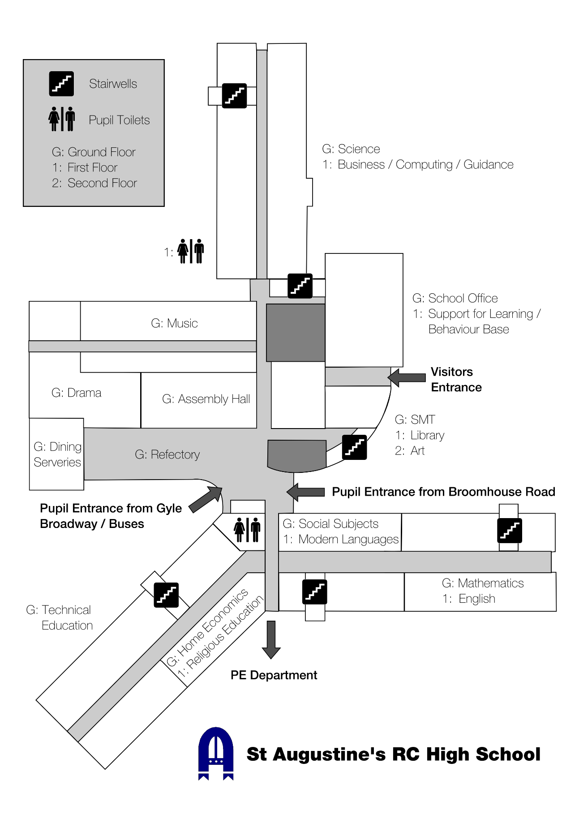

**MAP OF SCHOOL:**

**SCHOOL VISION, VALUES and AIMS:**

**VISION:** St Augustine’s provides a welcoming and friendly environment, celebrating inclusion and diversity, providing high quality learning to enable all young people to achieve their potential.

**VALUES:** In our Catholic School we value **PRAISE**:

**P**otential

**R**espect

**A**chievement

**I**nclusion

**S**upport

**E**quality

**AIMS:** To ensure all young people fulfil their potential we aim to:

* Work in partnership with parents and carers and the wider community
* provide high quality learning experiences
* provide a curriculum which meets the needs of all learners
* provide support for all based on the Gospel values
* ensure that we Get it Right for Every Child

**PROMOTING POSITIVE BEHAVIOUR FOR LEARNING:**

We have a small number of rules that we expect all our students to follow. We express them *positively* to bring out the best in you. At St Augustine’s we aim to provide positive support for learning. We try to ensure that we give praise a high priority.

We reward positive behaviour with our ClassCharts scheme, for when you:

* make better progress than expected
* produce outstanding pieces of work
* show a real improvement in attitude
* work consistently in class
* show support for other pupils
* make a positive contribution to the school

Sadly, there are times when things don’t go well. St Augustine’s is a Restorative School, and we like to put things right. When you have behaved badly, your teacher will conduct a Restorative Conversation. This is where both you and the teacher talk about what happened to **put things right.**

**UNIFORM:**

St Augustine’s is proud of its school uniform. We expect you to wear it because:

* it emphasises that school is a place of work.
* it shows that you belong to a community.
* It makes it easy for us to recognise you so that we can guarantee your safety.
* it shows that St Augustine’s is a school committed to high standards.

Our school uniform comprises:

* black tailored trousers or skirt of a suitable length
* white school shirt
* school tie
* black school shoes (no boots, including ankle boots)
* blue, school blazer with school badge (for years S5 & S6)
* A black school **v-neck** cardigan/**v-neck** jumper will be acceptable over a white school shirt and school tie. You will be given a tie at your 3-day visit.
* Pupils should wear clothing that shows the St Augustine's badge.
* Jeans, black jeans, joggers, leggings, jeggings, trainers, designer tops, caps and boots (including ankle boots) are not appropriate school wear.

Lockers are available for pupils to store outdoor garments such as boots and jackets or your PE kit.

**PE KIT UNIFORM:**

The PE department at St. Augustine’s implement a PE kit uniform for pupils. This applies to all pupils from S1-3.

Pupils will be required to bring the following items for PE classes:

* **Plain White, black, grey or navy t-shirt** (this should be plain with no logos/writing and **NOT** a vest top)
* **Black, Navy or grey shorts or tracksuit trousers or suitable sports leggings**
* **Change of footwear** – suitable for PE activities
* **A warm top/rain jacket would be optional in bad weather.**

The only time pupils would require different equipment would be when the class are on **swimming**. For swimming class, pupils will require (they are welcome to wear a t-shirt on top too):

* a swimsuit **or** trunks **or** shorts
* a towel

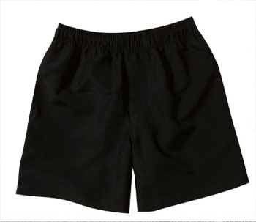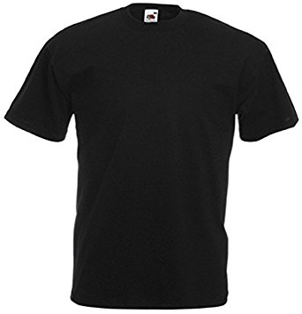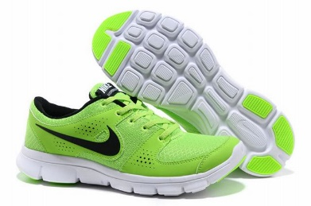

**FREQUENTLY ASKED QUESTIONS:**

There is lots of information on our school website [www.st-augustines.edin.sch.uk](http://www.st-augustines.edin.sch.uk) if you have any other questions. Scan this QR code for the school website:

|  |  |
| --- | --- |
| *How do lunch cards work?* | To buy lunch you need to use a YoungScot card which you will be given by the school in August. You may have used a similar “cashless catering system” in Primary. You can put money onto your card at the start of the day or at breaktime in the machines in the dining room. |
| *What to do if you are late?* | If you are late but arrive before 9am you must go straight to class. If you arrive after 9am you must sign in at the front office and report to Maths Room 4 at lunch. Your parents will receive a ‘late call’ if you are late. |
| *What to do if you are absent?* | If you know in advance that you are going to be absent, your parents must phone the school or write a letter explaining why you will not be in.  If you are absent and your parents have not written a letter or phoned the school, they will receive an Absence call which asks you to let us know why you are off school.  The school phone number is 334 6801 |
| *What to do if you are feeling sick?* | Pupils should report to the sick bay at the front office if they feel unwell. If you need to go home, Mrs Bailey may phone your parents and ask them to come and collect you.  ***You must not leave school without permission or phone parents to come and collect you. OUR SCHOOL OFFICE WILL CALL THEM.*** |
| *I am worried about anything?* | Talk to your Pupil Support Leader or Tutor Teacher, in the first instance. |
| *I need to take medicine at school?* | Collect a form from the school office. This should be completed and signed by your parent/guardian.  Return the completed form with the required medication to the school office. |
| *I lose personal items?* | Ask at the school office.  The school is not liable for the loss of personal items such as mobile phones or jewelry.  **Do not**bring valuables to school. |
| *I find personal items?* | Be a good citizen and hand them in at the school office. |
| *I see a fire?* | Keep calm and tell an adult |
| *The Fire Alarm goes off?* | Listen carefully to the teacher’s instructions:  • Leave your bags behind in the room  • Leave the building by the exit directed by the teacher  • Assemble in your designated area  • Remain calm and orderly  • Only re-enter the building when instructed to do so by staff |
| *How to apply for a YoungScot Card?* | * Application forms from the school office or your local library * A qr code with dots    Description automatically generated with medium confidenceYoung Scot Infoline – 0808 801 0338 * Email – [info@youngscot.org](mailto:info@youngscot.org) * Replacement cards from – 0131 200 2350 * Scan this QR code: |

**PUPIL SUPPORT STAFF:**

Here are some of the key members of staff who will support you in your time at St Augustine’s in addition to all our classroom teachers.

|  |  |  |  |
| --- | --- | --- | --- |
| **SENIOR LEADERSHIP TEAM (SLT)** | | | |
| The Senior Leadership Team consists of:  the Headteacher (Mr O’Doherty), the Deputy Head Teachers (Mrs Baird, Mr Frew and Mr McLauchlan) and the Business Manager (Mr Carter). | | | |
|  | C:\Users\4014515\AppData\Local\Microsoft\Windows\Temporary Internet Files\Content.Outlook\27STENSC\IMG_1845.jpg | |  |
| Mr O’Doherty (HT) | Mrs Baird (DHT) | | Mr Frew (DHT & S1 Year Head) |
|  | C:\Users\4014515\AppData\Local\Microsoft\Windows\Temporary Internet Files\Content.Outlook\27STENSC\IMG_1839.jpg | |  |
| Mr McLauchlan (DHT) | Mr Carter (Business Manager) | |  |
| **INTEGRATED PUPIL SUPPORT (IPS) TEAM** | | | |
| C:\Users\4014515\AppData\Local\Microsoft\Windows\Temporary Internet Files\Content.Outlook\27STENSC\IMG_1840.jpg | |  | C:\Users\4014515\AppData\Local\Microsoft\Windows\Temporary Internet Files\Content.Outlook\27STENSC\IMG_1832.jpg |
| Ms Kelly (St Andrew House) | | Mrs Kelly (St David House) | Mrs McKillop (St Margaret House) |
|  | | You will have a Pupil Support Leader [Ms Kelly (St Andrew House), Mrs Kelly (St David House), Mrs McKillop (St Margaret House) or Ms Souness (St Bernadette House)] who is there to support you throughout your time at school.  You will hopefully have met them during your 3-day visit. Your parents can also meet them at the parents’ evening and can contact them at any point on 0131 334 6801 if there is anything they are concerned about. | |
| Ms Souness (St Bernadette House) | |  | |
| Our Integrated Pupil Support Team also includes our Support for Learning Leader (Mrs Heeps, who will be on maternity leave until May 2024) and Mrs Zamarlik (who will be acting up in Mrs Heeps’ place), as well Mrs McCallum who is our Transition Teacher. They work in our Pupil Support Department which is on the first floor. | | | |
| C:\Users\4014515\AppData\Local\Microsoft\Windows\Temporary Internet Files\Content.Outlook\27STENSC\IMG_1834.jpg | | C:\Users\4014515\AppData\Local\Microsoft\Windows\Temporary Internet Files\Content.Word\IMG_1837.jpg |  |
| Mrs Heeps (CL of SFL – on maternity leave) | | Mrs Zamarlik (Acting CL of SFL) | Mrs McCallum (Transition Teacher) |
| C:\Users\4014515\AppData\Local\Microsoft\Windows\Temporary Internet Files\Content.Outlook\27STENSC\IMG_1843.jpg | | | |
| Our Pupil Support Assistants (above) will also help you in your classrooms. | | | |
|  | | C:\Users\4014515\AppData\Local\Microsoft\Windows\Temporary Internet Files\Content.Outlook\27STENSC\IMG_1842.jpg | C:\Users\4014515\AppData\Local\Microsoft\Windows\Temporary Internet Files\Content.Outlook\27STENSC\IMG_1830.jpg |
| Mrs Whyte (The Hub) | | Mr Milne (Inclusion Development Officer) | Mrs Gibson – Claire (Pupil Support Officer) |
|  | | We also have Mrs Whyte who is in charge of the Wellbeing Hub, and our Development Officer for Inclusion (Mr Milne) who runs our inclusion program.  We also have our Pupil Support Officer for Wellbeing (Mr Bell – known as Callum) who runs lots of wellbeing related acitvities; and our Family Liaison and Pupil Support Officer (Mrs Gibson – known as Claire). | |
| Mr Bell – Callum (Pupil Support Officer) | |  | |

|  |  |
| --- | --- |
| **P7 TRANSITION PASSPORT** | |
| **SUBJECT** | **THOUGHTS / FEELINGS / REFLECTIONS / THINGS YOU LEARNT** |
|  |  |
|  |  |
|  |  |
|  |  |
|  |  |
|  |  |
|  |  |
|  |  |
|  |  |
|  |  |
|  |  |
|  |  |

**IN ST AUGUSTINE’S, WHERE DO I HAVE OPPORTUNITIES TO BE…?**

|  |  |
| --- | --- |
| **NURTURED** | **ACTIVE** |
|  |  |
| **ACHIEVING** | **RESPECTED** |
|  |  |
| **HEALTHY** | **RESPONSIBLE** |
|  |  |
| **SAFE** | **INCLUDED** |
|  |  |

**Dear Future Me**

I am about to leave \_\_\_\_\_\_\_\_\_\_\_\_\_\_\_\_\_\_\_\_\_\_\_\_\_\_\_Primary and start St Augustine’s RC High School.

Here are some interesting facts about me now - which I will read again when I leave St Augustine’s, at some point in the future!

**My favourite song is:**

**My favourite music band or group is:**

**My favourite food is:**

**My favourite joke at present is:**



**My favourite television programme is:**

**In my free time, I like:**

**My favourite outfit is:**

**My time at Primary**

**My favourite teacher was:**

**My friends at Primary are:**

**My favourite part of Primary school is:**

**My best school trip was:**

**My funniest memory of Primary is:**

**The future…**

**Starting St Augustine’s, I am most excited about:**

**Starting St Augustine’s, I am nervous about:**

**The subject I am most looking forward to is:**

**I would like to visit:**



**I would like to be:**



**What would you like to be remembered for once you leave St Augustine’s?**