S4-S5 Learning Review
Course Choice Form 2025 – 2026
Please note the following:
- Pupils will submit their course choice options online aided by their Pupil Support Leader.
- This form must be completed first and then signed by a Parent/Carer before courses can be submitted.
- Once courses have been chosen it may not be possible to change to another subject. Pupils must take time to investigate subjects and career paths to be sure about their choices.

Please note the following:
- Prior engagement and attainment will be considered. For example, pupils achieving Grade Ds/7 in their final National 5 exam will not be able to progress on to Higher.
- Resitting subjects – Pupils that fail a subject or gain a grade D/7 may not be able to resit this due to class numbers.

Free Choice/Selection
Pupils will have free choice and can choose any subject on offer. However, there are some important points to consider.

- Some subject choices may not be possible (oversubscription/clashes with other subjects/lack of numbers).
- We encourage Pupils and Parents/Carers to follow staff advice when selecting particular subjects. For example, during Parents Evening or Tracking Reports.
- Prior learning in a subject could be taken in to consideration if necessary.
- Pupils and Parents/Carers should refer to the Learner Pathways Information booklet and Parent Powerpoint Presentation for further details.
- Pupils should also think about their career path and what they would like to do when they leave school so that they understand what subjects they should be taking that will support this career choice.

Compulsory Subjects:
- Religious Education (1 period per week)
- Caritas/Leadership (1 period per week)
- Personal Social Education (1 period per week)

In addition, five further subjects must be chosen from the options on the next page. Pupils should also select 2 reserve choices. This is in case some of their subject choices are not possible.

Pupils will be asked to choose subjects by preference. For example, if they are very keen to take French, this should be one of their first choices.

Advanced Higher Courses
Some may not be able to run. If this is the case, pupils may be able to access courses via our online consortium. Pupils Support Leaders will have more information about this.
Key Points:
- These will run predominately online (via Teams) with occasional visits arranged to the host school.
- Pupils can access these courses at home if their timetable allows and does not impact on their other classes at St Augustine’s.

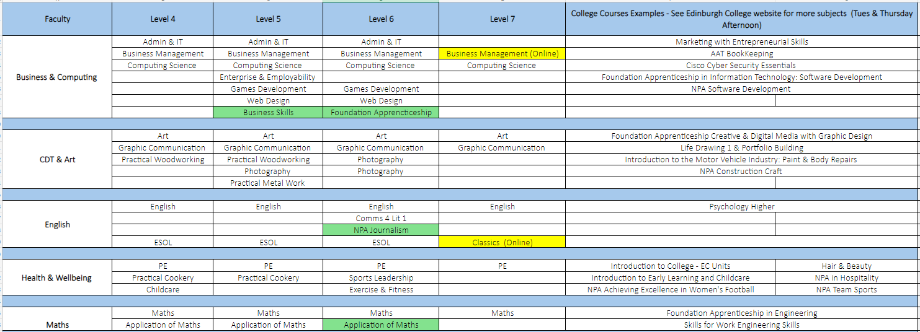
Course Choice Options

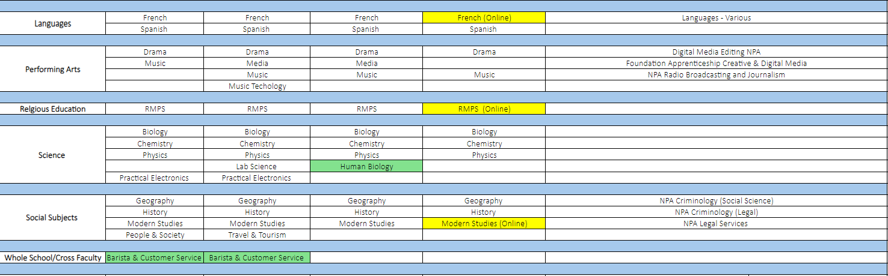

College Courses – Click here or type in www.edinburghcollege.ac.uk/courses/for-school-pupils
Course Choice Form
Pupil Name |  |  | Tutor Group
Current Subject |  | Current Level | Formal Assessment Result/Target Grade
Pathway
Career Choice
Entry Requirements

Course Choice Sheet
Pupil Name |  |  | Tutor Group
Priority | Subject Choice | Recommended Level of Study | Subject Teacher  Signature
1

2

3

4

5

Please add 2 reserve choices (by preference)

Reserve 1

Reserve 2

Pupil Signature |  |  | Date
Parent/Carer Signature |  |  | Date
PSL Signature |  |  | Date

College - If choosing college, please state “COLLEGE & COURSE”
Please gather Recommended Level information from your teacher.
Next Steps
Once this form is completed, these options should then be entered online using your personal login details. Your PSL with have this information.

